# Appendix -3: Facility Numbers

**Note**: Facility 976 (Sinai Health System) cannot be entered in the Shared Care Facility column

|  |  |  |  |
| --- | --- | --- | --- |
| **#** | **Program Title** | **Submitting Hospital** | **Facility Number** |
| 3 | Acute Leukemia | University Health Network | 947 |
| Lakeridge | 952 |
| Southlake | 736 |
| Trillium Health Partners | 975 |
| Sunnybrook | 953 |
| Royal Victoria Regional Health Center | 606 |
| Sinai Health System | 976 |

# Appendix-11: Valid 2-digits Postal Codes

(Source: Cancer Care Ontario's Data Book - 2012-2013, Appendix B - Province and State codes, at link https://www.cancercare.on.ca/ext/databook/db1213/databook.htm).

The table below provides list of valid 2 digit postal codes for province and State codes.

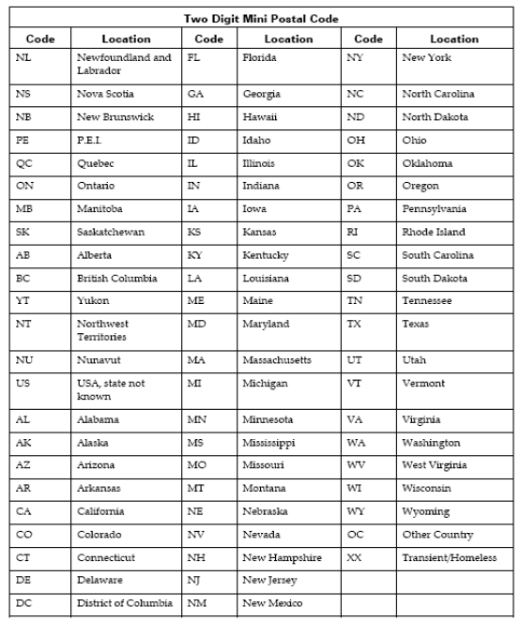

# Appendix-12a: Type of Leukemia

|  |  |
| --- | --- |
| **Name** | **Description** |
| AML | Acute Myeloid Leukemia |
| ALL | Acute Lymphoblastic Leukemia |
| Other Acute Leukemia | Acute leukemia other |
| Other Leukemia | Other leukemia |

# Appendix-13: MOHLTC Master Numbering System

The Master Numbering System has been developed for the purpose of bringing together all Health Facilities and Programs under one system of identification. The list is a composite of health and health related units, facilities, clinics, programs and services. Each such organization has been assigned a unique four digit identifying code.

(For details, please refer Cancer Care Ontario's Data Book - 2012-2013, Appendix A: MOHLTC Master Numbering System, at link <https://www.cancercare.on.ca/ext/databook/db1213/documents/Appendix/CCO_Appendix_A_APR_12.pdf>).